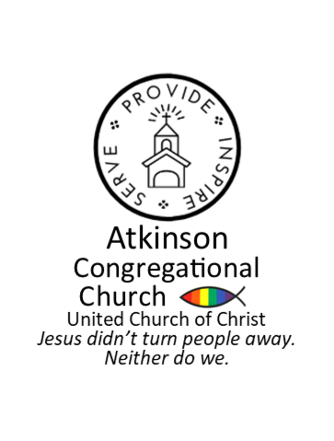
ATKINSON CONGREGATIONAL CHURCH

DORIS AND VIVIAN HORTON SCHOLARSHIP
APPLICATION FORM

Academic Year 2025-2026

To be considered for this scholarship, this application must be received no later than
June 13, 2025 and be accompanied by official transcripts to date of your college scholastic record. Incomplete applications will not be considered.

If insufficient space is allowed for your responses, please attach an extra sheet with this application. Official transcript is required.

- Name _____________________________________________________________

- Date of Birth ________________________________________________________

- Address and Phone No. _______________________________________________
____________________________________________________________________
____________________________________________________________________

- Name of Institution currently attending __________________________________

- Name of Institution you will attend next year _____________________________

- Address of Institution _________________________________________________ ____________________________________________________________________
____________________________________________________________________

- Anticipated year of graduation _________________________________________

- Name(s) of Parent(s) or Guardian(s) ___________________________________

- Place(s) of Parents’/Guardians’ Employment _____________________________

_________________________________________________________________________________

10. How many brothers do you have? _______ Ages ________________________

11. How many sisters do you have? _________ Ages ________________________

12. How many family members will be full-time college students next year? ______

(over for second page)
13. Annual family income as reported on Federal Income Tax form for the current
year _______________________________________________________________

14. List financial resources available with amounts:

Scholarships ___________________
Summer/Part-time Work ___________________
Family Contributions ___________________
Educational Loans ___________________
Savings ___________________
Other ___________________

15. Total cost of college for the coming year _________________________________

16. What will be your chosen major course of study? _________________________

17. What are your plans after graduation?
___________________________________________________________________
___________________________________________________________________
___________________________________________________________________
___________________________________________________________________
___________________________________________________________________
___________________________________________________________________

18. How long has your family been members of the Atkinson Congregational Church?
___________________________________________________________________

19. How long have you been a member of the Atkinson Congregational Church?
___________________________________________________________________

20. Have you participated in the church? Please explain.
___________________________________________________________________
___________________________________________________________________
___________________________________________________________________

- Please attach a brief essay stating the reasons why you think you deserve this
scholarship.

Signature ____________________________________ Date ____________________

Please submit application no later than June 13, 2025 to: Atkinson Congregational Church
Attn: Scholarship Committee
101 Main Street
Atkinson, NH 03811
Email to: office@atkinsoncc.org

